**SMALLPOX PREVENTION**

**TEAM MEMBERS**

G. SURAJ (2103A52136)

C.CHAITANYA GANESH DEV (2103A52009)

D. SAKETH REDDY (2103A52178)

# ABSTRACT

Smallpox, a deadly virus, has afflicted people for centuries. However, one of the most important milestones in public health came with the revelation of eradications of small pox declared by the World Health Organization (WHO) in the 1980s after years of unprecedented research on vaccines, preventions

Smallpox Prevention: Methods from Tradition and Current Vaccination Plans Summary.

In reality, for many centuries there has been a kind of smallpox-related resistance that exists from the very initial stages. People have knowingly infected themselves with smallpox purposely to gain some resilience.

Although the disease is not now a threat itself, it should remain a thing of the past necessitating continuing care and planning.

INTRODUCTION:

Smallpox is caused by certain bacteria, which are very infectious in nature since they plague humankind for generations. The international campaign initiated by the World Health Organization (WHO) in 1980 which declared smallpox as eradicated or eliminated constituted a major success for public health. However, the threat still exists because these virus samples exist securely in labs and can be released in the future through potential bioterrorism.

Machine learning is increasingly becoming a potent instrument in predicting and preventing outbreaks. The current age of technology coupled with data analysis makes it so. Many machine learning models have successfully predicted the spread of many infectious diseases such as influenza, Ebola, and COVID-19. This concept may also predict the possibility of smallpox.

This is a novel development based on historical data as well as genetics and epidemiology which creates forecasting models for prediction of developing mild flu cases, measuring their intensity, and advising further actions. Machine learning models come in handy during an outbreak, offering early detection, rapid response, and effective distribution of resources.

Although important from a historical perspective, there is the opportunity for learning about managing current and future epidemic emergencies as well as bioterrorism threats, the response strategies. Predicting Small-Scale Diseases with Machine Learning for Public Health Safety in Changing Environment.

LITERATURE REVIEW:

|  |  |  |  |  |  |
| --- | --- | --- | --- | --- | --- |
| S.N O | PAPER TITLE | MODEL USED | PARAMETERS | MERITS | DEMERITS/LIMITATIO N AND DRAWBACKS |
| 1 | Smallpox in history: the birth, death, and impact of a dread disease  J Lab Clin Med.  2003 Oct | Data Compilation and Analysis and  Epidemiological l Analysis. | Smallpox Prevention  Measures, Blood-Related  Interventions,  Transmission Risks,  Ethical Considerations,  Historical Context, Modern Implications, Conclusion. | The smallpox prevention measures in 19th century Naples had merits in containing outbreaks, building immunity, and laying the groundwork for vaccination. | The transmission of bloodborne pathogens, unpredictability of outcomes, lack of standardization, limited scientific understanding, ethical concerns, lack of informed consent, social disparities, and limited effectiveness. |
| 2 | The eradication of smallpox--an overview of the past, present, and future.  Henderson DA.  2011 Dec 30 | Removal of Smallpox.  Ethical  Confusion.  Controversial Eradication Methods. | Public Health Impact.  Unpleasent Reactions.  Perceived Overreach. | Revolutionized Disease Prevention.  Safety  Improvements.  Limited  Vaccine  Availability.  VaccineAssociated  Complications. | Adverse Reactions and Complications  Potential for Transmission.  Storage and Distribution Challenges.  Safety Concerns |
| 3 | Why not destroy the remaining smallpox virus stocks.  Voigt EA  2016 Sep;15 | Participant Selection and Ethics.  Enzyme-Linked immunosorbent nt Assay (ELISA).  Quantification and Antibody Specificity and Breadth Analysis | Vaccine Composition.  Antibody Titer and Avidity.  Breadth of Immune Response. | Understanding Vaccine Safety.  Vaccine  Efficacy  Comparison  Optimization of Vaccine Strategies.  Identification of Immune Targets. | Limited Focus on Other Immune Components.  Varied Immune Responses.  Incomplete Protection Evaluation.  Time-Dependent Responses. |

|  |  |  |  |  |  |
| --- | --- | --- | --- | --- | --- |
| 4 | What was the primary mode of smallpox transmission  Milton DK.  2012;2:150 | Historical Analysis Model.  Literature  Review Model.  Qualitative Analysis Model.  Contextual Analysis Model.  Comparative Model. | Historical Context, Key  Insights, Implications for  Smallpox Prevention,  Influence on Eradication Efforts,  Lasting Impact. | Historical  Contextualization n.  Preservation of Medical History.  Educational Value.  Effect on public Health.  Ethical  Reflections. | Selective Interpretation.  Anachronism.  Limited Sources. Overemphasis on a Single Work.  Lack of Primary Data. |
| 5 | Diagnosis and management of smallpox  Breman JG, 2002 Apr | Archival Analysis.  Interdisciplinar y Approach.  Comparative Analysis.  Qualitative Analysis. | Epidemiological Data.  Documentation of Prevention Measures.  Comparative Analysis. | Text Mining and  Natural  Language  Processing.  Predictive Modeling for Disease Spread. Automated Data Compilation. | Limited Data Availability. Data Quality and Accuracy.  Changing Definitions and Practices. |

|  |  |  |  |  |
| --- | --- | --- | --- | --- |
| 6 | Development and experience with an algorithm to evaluate suspected smallpox cases in the United States.  Seward JF, 2004 Nov 15 | models include  linear regression, decision tree, random forest,  elastic net, and  ARIMA. | These parameters include mortality rate, geodetic variables, confinement length, health supplies, and accessibility. These parameters are used to evaluate and analyze smallpox cases worldwide. | Overfitting Risk: Decision trees can overfit, excelling on training data but faltering on new, unseen data.  Data Sensitivity: Small data changes can  lead to varied tree structures and predictions.  Complexity |
| 8 | Clinical Features,  Prevention, and Management. Author: Roy Guharoy, Robert. Published:2003 | Eradication of Smallpox.  Controversial  Eradication Methods. | Isolating the infected person for a minimum of 17 days  is crucial in treatment. Healthcare workers must use proper precautions like gloves, gowns, masks, and shoe covers to prevent disease spread. | Smallpox eradicated in 1980.  Achieved through effective smallpox vaccine.  Demonstrates vaccination's disease control prowess. |
| 9 | Smallpox, vaccination and adverse reactions to smallpox vaccine. Curr Opin Allergy Clin Immunol.  Wollenberg A  2004 Aug;4 | Historical  Analysis and  Prospective  Assessment | The smallpox vaccine elicits a spectrum of adverse effects, spanning mild (fever, soreness) to severe (death, encephalitis). Reactions are more frequent in firsttime recipients, with higher fatality rates among them. | Smallpox vaccine, despite risks, is crucial for control.  Developed in the 1950s, enhanced with a bifurcated needle.  Global eradication via mass campaigns and ring vaccination.  Last natural case in 1975; disease was eradicated 1980. |
| 10 | Hyperimmune Antivaccine Gamma globulin Author: S. S. Marennikova 2018 Jan 29 | Clinical Case  Studies and  Comparative  Analysis | The document outlines the prophylactic and therapeutic parameters of hyperimmune antivaccine gamma-globulin. It extended incubation and infectious periods in animal experiments but didn't prevent death. | The document explores hyperimmune antivaccine gamma-globulin's prophylactic role in smallpox prevention and treatment.  Experimental use reduces disease severity and improves patient condition.  Administered during prodromal and peak stages with positive outcomes. |

Use of Machine Learning in Smallpox Prediction:

*Early Detection and Surveillance:*

*Anomaly Detection*: The Machine-learning algorithms are capable of analysing historical information on smallpox outbreaks, quantity of the cases, the place where they occurred, and the seasonality. Machine Learning algorithms can keep an eye out for references of Symptoms and associated keywords in social media and news.

*Diagnostic Support***:**

*Symptom Analysis***:** In order to offer approximate probabilities of the possibility that a patient has smallpox or another infectious illness with similar symptoms

*Epidemiological Modelling:*

*Predictive Modelling:*A Prediction model that projects the future spread of smallpox based on

variables including the number of people living nearby, vaccination rates, and movement patterns

may be created using machine learning.

*Vaccine Distribution:*

*Optimizing Vaccination Campaigns:* By taking into consideration variables like local smallpox transmission risk, transportation infrastructure, and population demographics

*Contact Tracing:*

*Contact Identification*: In order to stop the spread of the disease, machine learning can help

determine the most important those who may have come into contact with infected people

PROBLEM OBJECTIVE

The problem in predicting smallpox outbreaks using machine learning is to develop a model that can accurately predict the likelihood and likely regions of smallpox epidemics based on historical data, biological parameters, and surrounding factors. Understanding these facts will help professionals develop strategies to control and stop the progression of the disease, ultimately resulting in the saving of lives and a reduction in the impact of smallpox outbreaks.

Predicting the smallpox epidemic using machine learning requires the utilization of data-driven strategies in fighting a major public health challenge. An explanation of the problem objective is provided below:

* *Data-Driven Prediction:*

The main goal lies in creating data-based predictions about the outbreaks and spread of the smallpox pandemic through machine learning methods. Historical data must therefore be collected about Smallpox cases, outbreaks, and other issues.

* *Early Detection:*

One of the goals in finding the future outbreak of smallpox is early detection. Machine-learning-based algorithms can learn how to detect trends or anomalies, and this capability could assist them in predicting the start of an epidemic earlier on, when it is not already widespread.

METHODOLOGY:

*Data Sources:*

The data for this project was accumulated from different sources which included, among others,

historical data, resident accounts and civic statutes

*Data collection and integration:*

Data is drawn from these sources.

*Preliminary data:*

At this stage, data is cleaned, processed and converted so that it can be used for machine learning.

*Machine Learning Models:*

Prediction vs Errors – Several Learning Models Exists.

*Distributed Models:*

Real-time monitoring is done through trained models.

*Notification and Communication:*

Thereafter, the system notifies the relevant organs of authority with a comprehensive risk analysis.

*Ethical issues and confidentiality:*

The use of health information is sensitive to ethical issues and confidentiality.

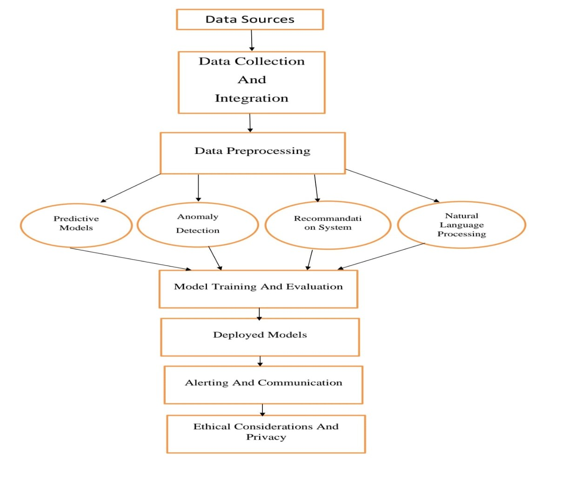

Fig-1: Architecture

DATASET DESCRIPTION:

Small_Pox_Cases_Worldwide **:** This dataset contains a tally of confirmed and suspected cases in all the countries.

Worldwide_Case_Detection_Timeline**:** This dataset contains the timeline for confirmed cases w.r.t. date time, it also contains some other details on every case that is being reported.

Daily_Country_Wise_Conformed_Cases**:** This dataset contains the daily number of confirmed cases for all the countries where the virus has entered.

Worldwide cases data: (56, 6)

Timeline case detection data: (1473, 9)

Daily country-wise cases data: (97, 111)

We used 3 datasets on smallpox prevention.

One is for smallpox the number of suspected cases.

The second is for the timeline.

The third is for confirmed cases for all the countries.

RESULT:

These are the major cities contaminated with smallpox (fig-2):

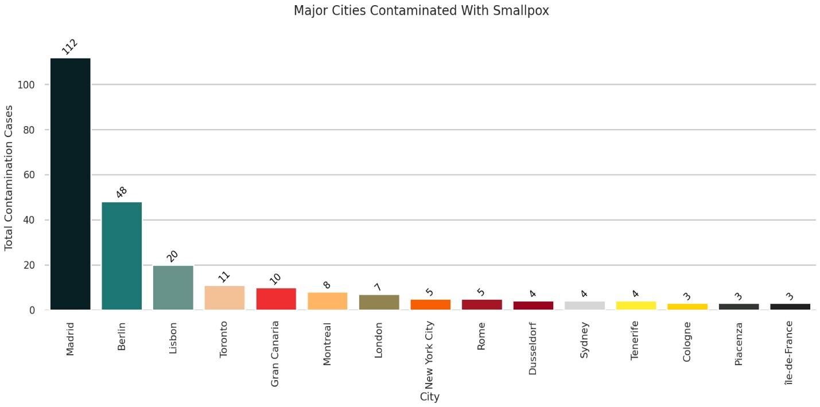

Fig-2

2.The countries affected with smallpox (fig-3):

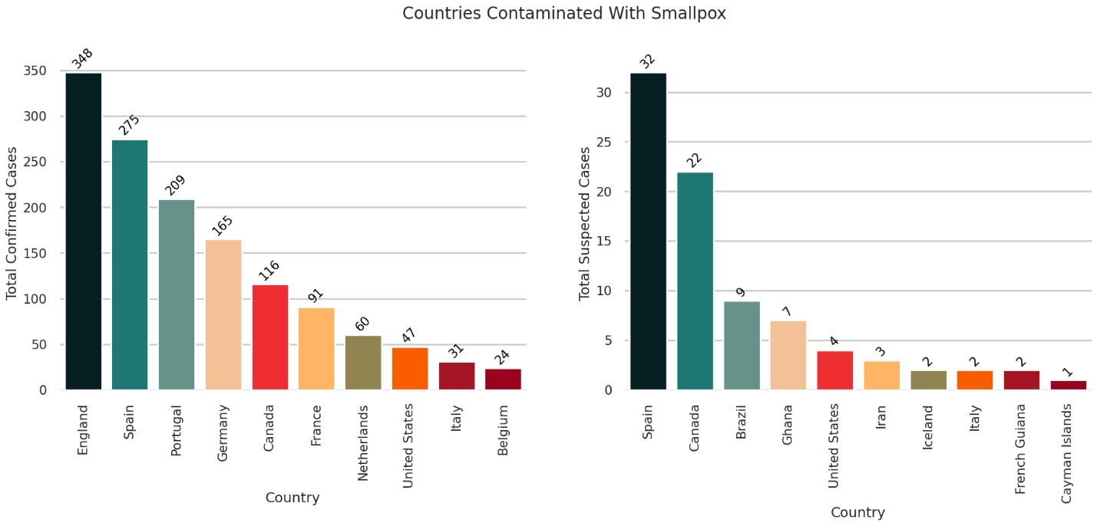

Fig-3

We can see that England is leading in confirmed cases followed by Spain and Portugal whereas Spain is

Leading in Suspected cases followed by Canada and Brazil

3. Top countries that are hospitalized with smallpox (fig-4):

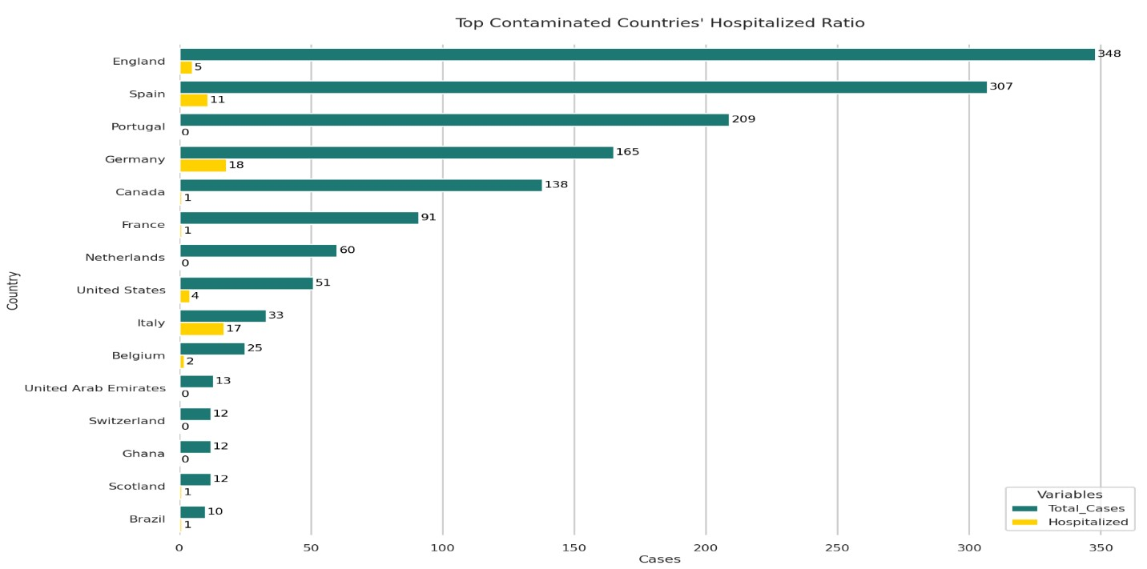

Fig-4

We can see **“England”** is leading in the overall number of cases but the number of hospitalized cases is not high whereas **“Germany”** is leading in hospitalized cases

4. This is the bar graph of country-wise hospitalized cases(fig-5):

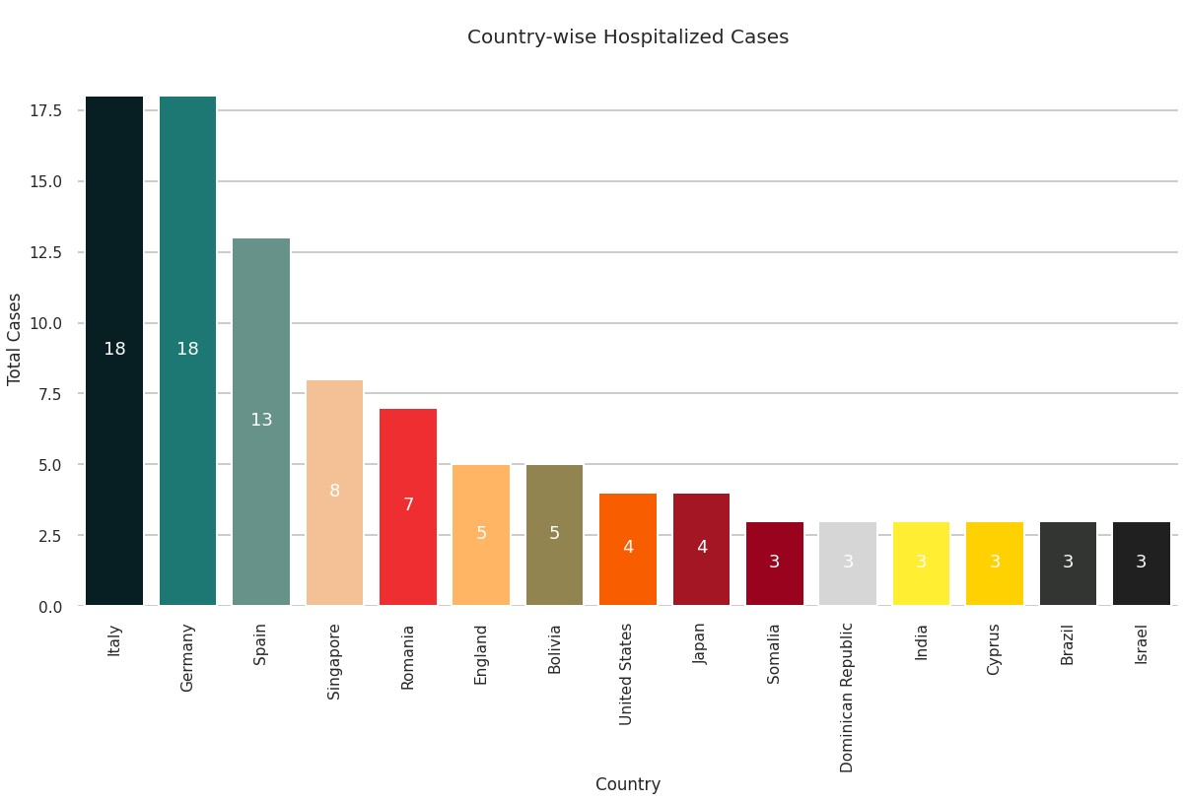

Fig-5

5.This is the country wise Travel history (fig-6):

Black represents Yes

Yellow represents No

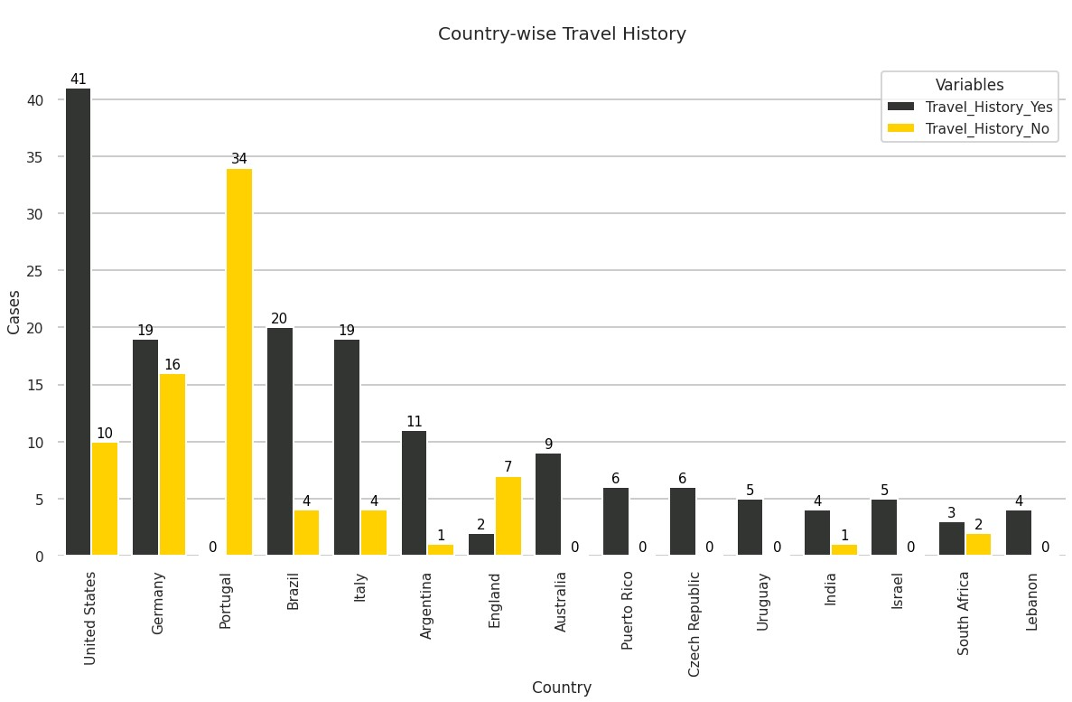

Fig-6

1. Occurrences in Symptom Wise (fig-7):

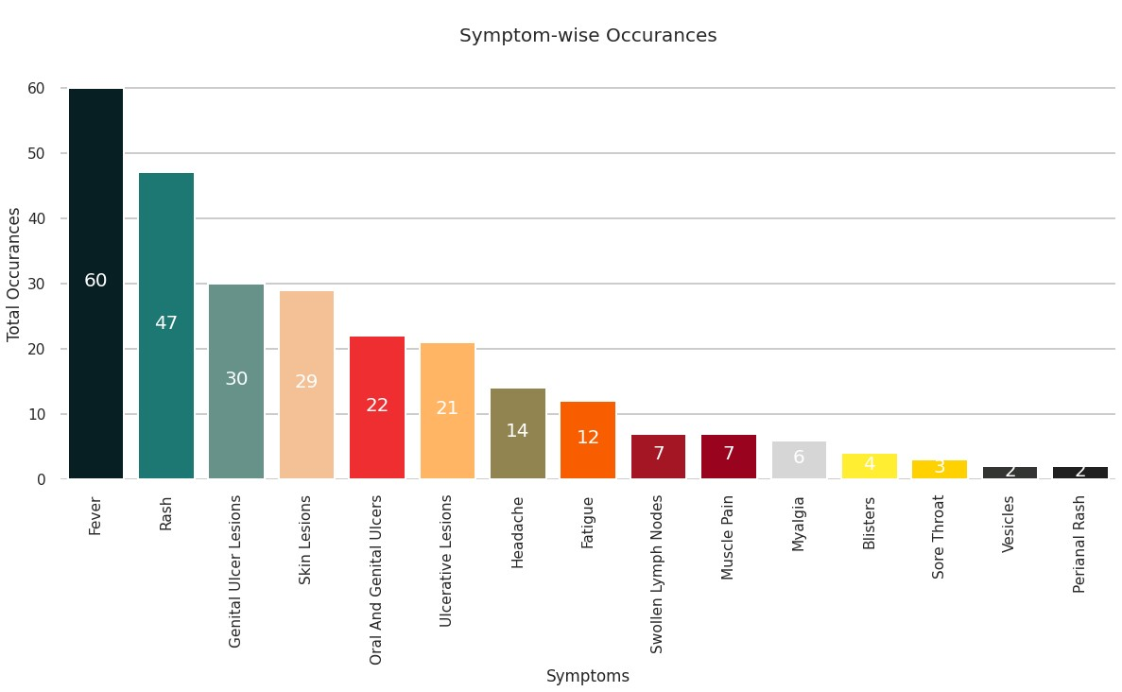Fig-7

1. The top 9 countries of smallpox confirmed cases and the number of patients in that country .The countries are as follows (fig-8):

1.England

2.France 3.Netherlands 4.Canada

5.Portugal

6.Brazil

7.Spain

8.United States 9.Germany

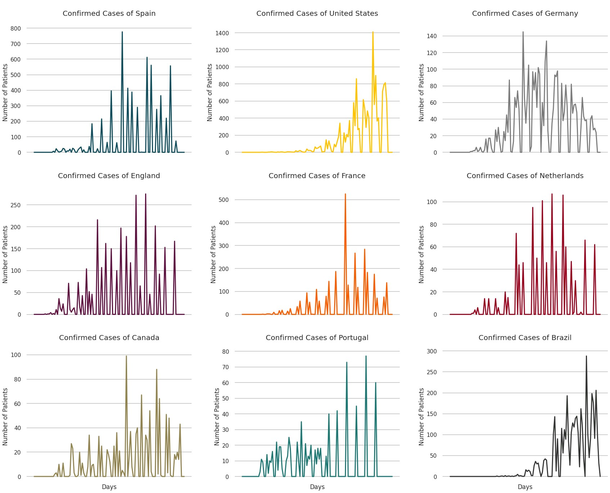

Fig-8

8.The top 9 countries contaminated with Smallpox (fig-9):

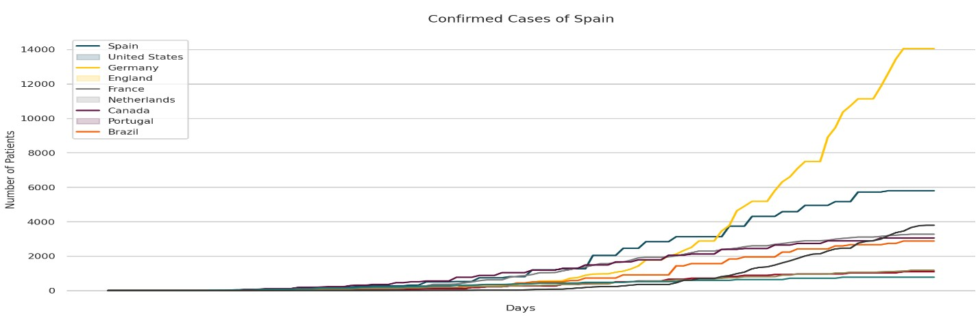

Fig-9

9. Correlation matrix of smallpox cases (fig-10):

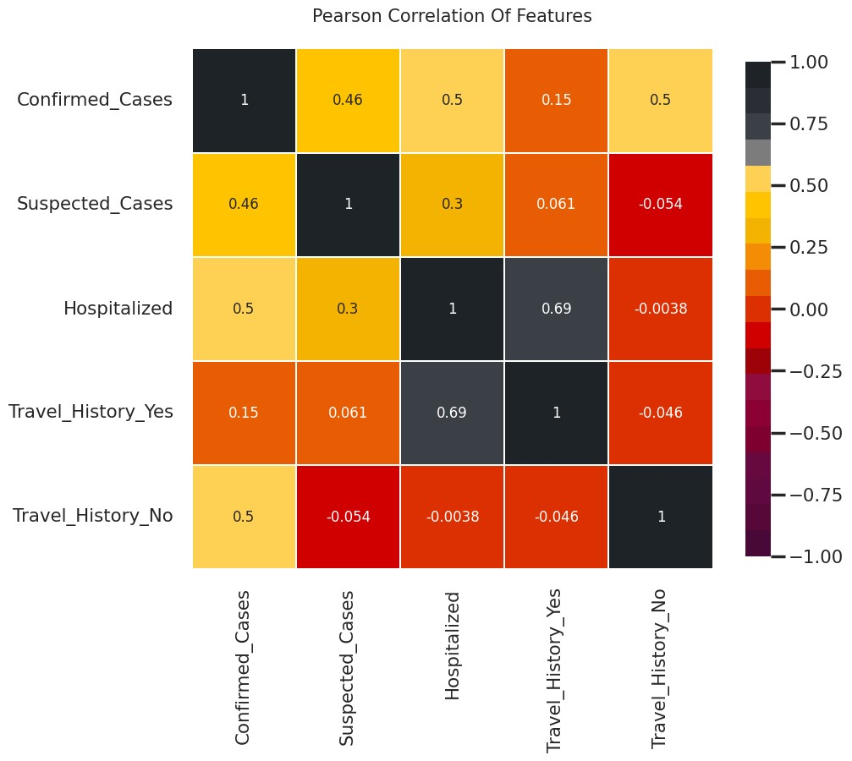

Fig-10

We can see that people with travel history have a positive correlation with confirmed cases and hospitalization.

CONCLUSION

The amazing journey of history, science and international cooperation led to the prevention of smallpox. This study highlights best practices in public health by providing detailed information on different strategies and actions that led to the eradication of smallpox.

Preventing smallpox has gone beyond preventing smallpox since Edward Jenner invented the vaccine. Jenner's discovery laid the foundation for modern vaccines and led to new discoveries that eventually led to the development of smallpox vaccines.  
  
The World Health Organization's (WHO) eradication of smallpox is a good example of the combination of cooperation and tolerance for humans. This important work includes widespread vaccination, strict surveillance and rapid response teams. The ultimate goal of eradicating smallpox from the world was achieved in 1980 through the collaboration of medical professionals, national governments, and international organizations.  
  
Even if the virus is eliminated from humans, it will continue to be used by bioterrorists in the future. For this reason, studies continue to improve smallpox vaccination programs, vaccines and vaccine products.  
  
In summary, research, international cooperation, and public health benefited from the war against smallpox. The eradication of smallpox is celebrated because it shows that people can overcome the most difficult diseases through dedication, skill and cooperation. It also serves as a reminder of the importance of vigilance, planning and constant research to ensure smallpox remains a thing of the past. The initiative highlights important lessons learned from small-scale antibiotic use and the continued importance of effective public health interventions.

FUTURE SCOPE

*Improved Vaccine Growth:* New research initiatives are always being developed to improve the available smallpox vaccinations. Future studies could concentrate on creating vaccines that are less likely to cause negative effects while also being safer and more effective. New vaccine delivery methods, such as oral or nasal administration, may be researched to speed immunization efforts*.*

*Biological Threat Readiness:* It is essential to carry out research in this field since smallpox might be utilized as a weapon by bioterrorists. To do this, it is essential to strengthen monitoring systems, develop rapid diagnostic methods, and fine-tune response strategies for potential smallpox outbreaks.

*Maintenance of Vaccine Stockpiles*: Having vaccinations against smallpox on hand is still crucial. Subsequent studies may assess the adequacy of vaccine reserves, including storage conditions and distribution strategies, to ensure prompt readiness in the event of an epidemic.

The complete eradication of smallpox is a key case study in the area of global health security. Future research may look at how the smallpox eradication experience affected frameworks and strategies for managing other infectious illnesses and medical emergencies*.*

GitHub Link: [dafefinalproject/Smallpox.ipynb at main · Gudassuraj/dafefinalproject (github.com)](https://github.com/Gudassuraj/dafefinalproject/blob/main/Smallpox.ipynb)

REFERENCES:

1. Henderson DA. The eradication of smallpox--an overview of the past, present, and future. Vaccine.

2011 Dec 30;29 Suppl 4:D7-9. [PubMed]

1. Lane JM, Poland GA. Why not destroy the remaining smallpox virus stocks? Vaccine. 2011 Apr

05;29(16):2823-4. [PubMed]

1. Voigt EA, Kennedy RB, Poland GA. Defending against smallpox: a focus on vaccines. Expert Rev

Vaccines. 2016 Sep;15(9):1197-211. [PMC free article] [PubMed]

1. Eyler JM. Smallpox in history: the birth, death, and impact of a dread disease. J Lab Clin Med. 2003 Oct;142(4):216-20. [PubMed]
2. Milton DK. What was the primary mode of smallpox transmission? Implications for biodefense.

Front Cell Infect Microbiol. 2012;2:150. [PMC free article] [PubMed]

1. Moore ZS, Seward JF, Lane JM. Smallpox. Lancet. 2006 Feb 04;367(9508):425-35. [PubMed]
2. Breman JG, Henderson DA. Diagnosis and management of smallpox. N Engl J Med. 2002 Apr 25;346(17):1300-8. [PubMed]
3. Seward JF, Galil K, Damon I, Norton SA, Rotz L, Schmid S, Harpaz R, Cono J, Marin M, Hutchins S, Chaves SS, McCauley MM. Development and experience with an algorithm to evaluate suspected smallpox cases in the United States, 2002-2004. Clin Infect Dis. 2004 Nov 15;39(10):1477-83. [PubMed]
4. Grosenbach DW, Honeychurch K, Rose EA, Chinsangaram J, Frimm A, Maiti B, Lovejoy C, Meara I, Long P, Hruby DE. Oral Tecovirimat for the Treatment of Smallpox. N Engl J Med. 2018 Jul

05;379(1):44-53. [PMC free article] [PubMed]

1. Mucker EM, Goff AJ, Shamblin JD, Grosenbach DW, Damon IK, Mehal JM, Holman RC, Carroll D, Gallardo N, Olson VA, Clemmons CJ, Hudson P, Hruby DE. Efficacy of tecovirimat

(ST-246) in nonhuman primates infected with variola virus (Smallpox). Antimicrob Agents Chemother. 2013 Dec;57(12):6246-53. [PMC free article] [PubMed]

1. Vora S, Damon I, Fulginiti V, Weber SG, Kahana M, Stein SL, Gerber SI, Garcia-Houchins S, Lederman E, Hruby D, Collins L, Scott D, Thompson K, Barson JV, Regnery R, Hughes C,

Daum RS, Li Y, Zhao H, Smith S, Braden Z, Karem K, Olson V, Davidson W, Trindade G, Bolken T, Jordan R, Tien D, Marcinak J. Severe eczema vaccinatum in a household contact of a smallpox vaccinee. Clin Infect Dis. 2008 May 15;46(10):1555-61. [PubMed]

1. Melamed S, Israely T, Paran N. Challenges and Achievements in Prevention and Treatment of Smallpox. Vaccines (Basel). 2018 Jan 29;6(1) [PMC free article] [PubMed]
2. Mota BE, Gallardo-Romero N, Trindade G, Keckler MS, Karem K, Carroll D, Campos MA, Vieira LQ, da Fonseca FG, Ferreira PC, Bonjardim CA, Damon IK, Kroon EG. Adverse events post smallpox-vaccination: insights from tail scarification infection in mice with Vaccinia virus. PLoS One. 2011 Apr 15;6(4):e18924. [PMC free article] [PubMed]
3. Wollenberg A, Engler R. Smallpox, vaccination and adverse reactions to smallpox vaccine. Curr Opin Allergy Clin Immunol. 2004 Aug;4(4):271-5. [PubMed]"